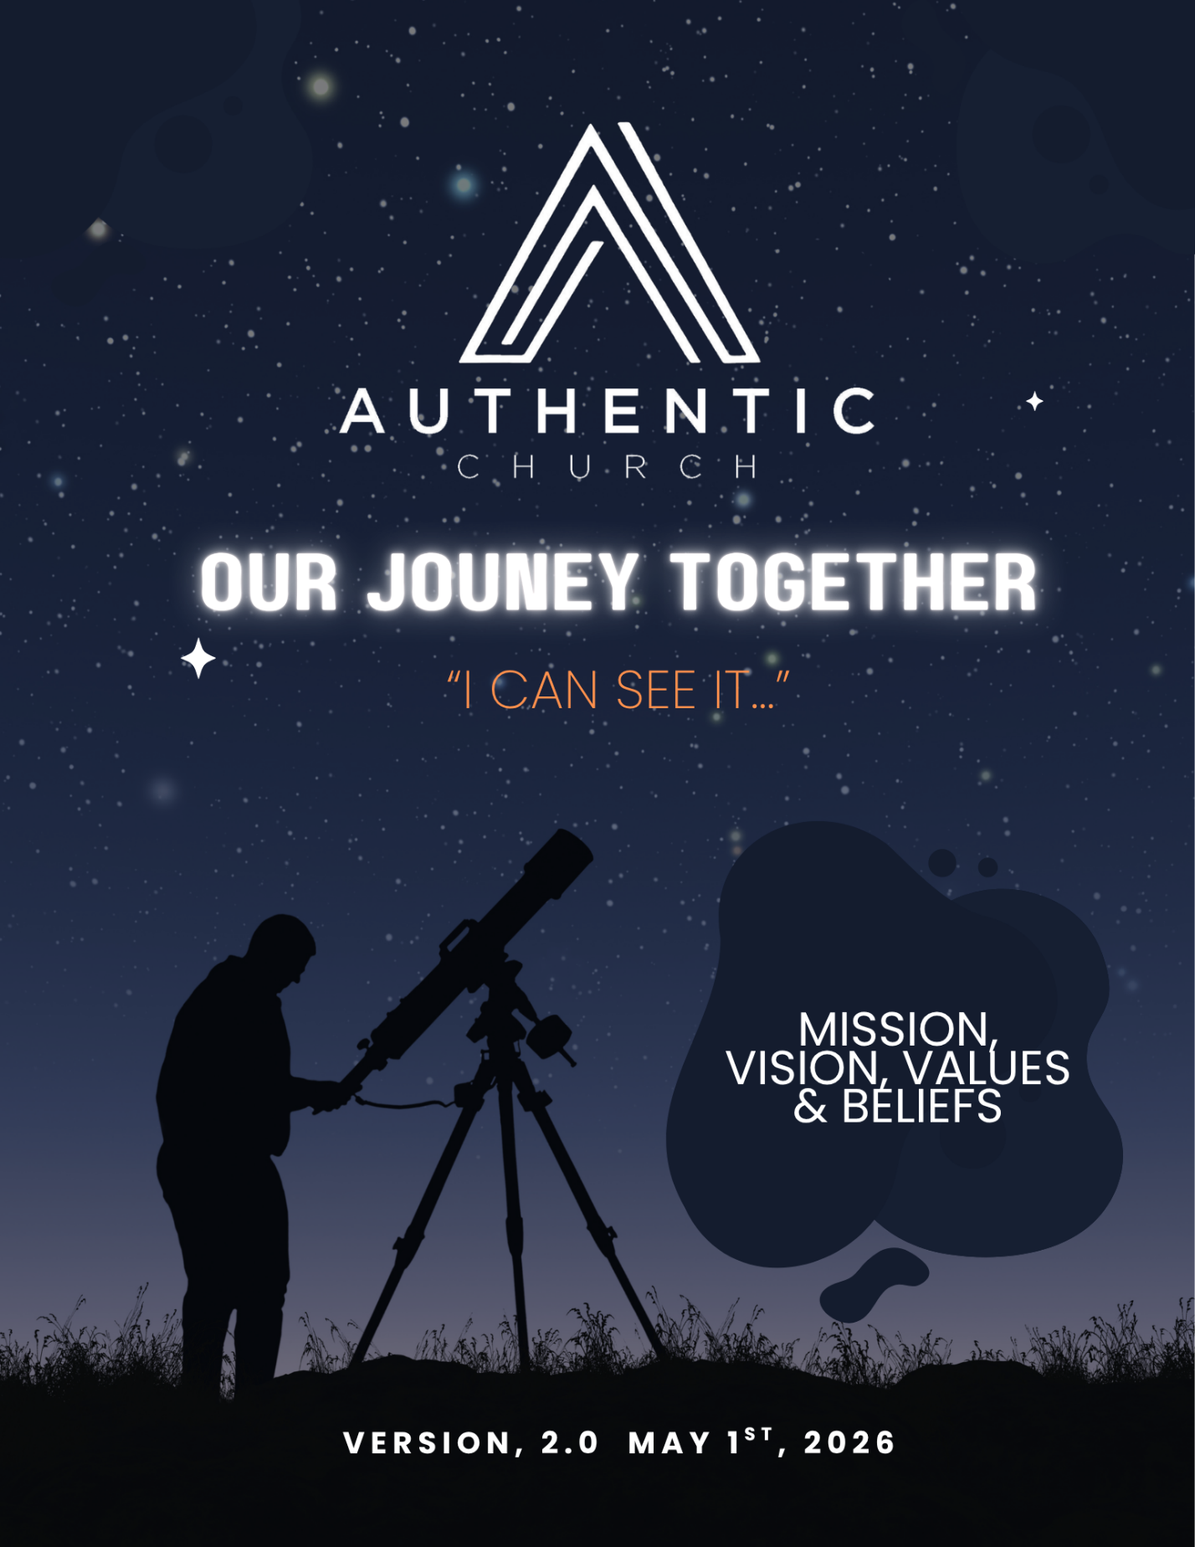

Our Mission
“Calling a Generation to an Authentic Faith in Christ”

Our Vision
To be a church desperately pursuing the heart of God, to know Him intimately and petition Him for a move of His spirit in East Tennessee… that shatters religious barriers, reconciles racial & ethnic divisions, heals brokenness, and empowers the church to truly become “the hands and feet of Jesus” to our neighbors!

We believe this move of the Holy Spirit, will lead to the establishment of Authentic Church in East TN. What does this church look like?

- Planting “TRADITIONAL CHURCHES” throughout East TN, focused primarily on the Maryville/Alcoa, Lenior City & Harriman/Rockwood areas.
These biblically based churches, directed by Holy Spirit led leadership teams, will serve as hubs of transformation, healing and restoration, teaching men & women to walk in partnership with the Holy Spirit and operate in His giftings, looking to raise up new leaders and launch new ministry efforts into our communities!

- Equipping spirit-filled, biblically-sound leaders to start TRIBES that gather in homes, community centers, coffee shops, businesses, softball fields, gyms, etc… allowing people to encounter God in unique settings, surrounded by biblical community, to help them grow in their faith and make a difference in their local neighborhoods!

- Connecting with other like-minded ministries that want to be a part of our MINISTRY NETWORK, supporting one another to fulfill our unique ministry callings and partnering together to expand the kingdom of God in our region.

Together, these different expressions of church will make up Authentic Church in East TN, giving us “a reach beyond one building,” but touching every segment of our region, as we cross-pollinate with other ministries that need a fresh encounter with the Holy Spirit!

In 10 years, this church may look like:
- Traditional spirit-filled, biblically-based churches, located in different cities, assisting in healing the broken, equipping the saints to walk in partnership with the Holy Spirit and operate in His giftings, and raising up leaders to launch new ministry efforts.

- Unique ministry gatherings, (such as TRIBES) that meet in various locations, helping men & women grow in their faith, equipping them to do the work of the ministry and effectively reach their neighbors.

- Establishing a ministry network, of various Christian faith expressions, that partner together to help others fulfill their unique callings and expand the kingdom of God in all segments of society.

- An annual mass gathering on Good Friday, with all the various ministries, to celebrate all that God has done in this unique, spirit filled ministry network. This will include celebratory worship, testimonies, baptisms, biblical instruction, and a demonstration of the Spirit’s power!

- Finally, we will host an annual conference, FIRE ON THE MOUNTAIN, to discuss further the person of the Holy Spirit, experience His power and equip others to walk in His supernatural gifts.

IF WE CAN SEE THIS VISION COME TO PASS, East TN will be marked by a move of the Holy Spirit, that will forever change the historical timeline, by the men & women that dared to follow His leadership.

Our Values

Knowing Scripture & A Lifestyle of Prayer
We are intentional about living a life of prayer and grounding ourselves in the truth of Scripture, seeking God’s voice and aligning our lives with His will, not our own.

Living in Biblical Community
We will meet regularly, to seek one another’s good, pursue deeper, more intimate relationship with Christ and to encourage one another to live out our faith. Together, we will declare His gospel message to those that have never heard and reach out in love to our communities.

Devoted to the Discipleship Journey
We dedicate ourselves to a lifelong discipleship process—growing, serving, and following Christ, under the guidance of the Holy Spirit, that we might become more like Christ.

Intentional About Our Unique Callings
We intentionally discover our unique God-given calling and live it out with courage, faithfulness, and total surrender, making a lasting difference in our world.

Marked by Extreme Generosity
We seek to be different than our culture, by giving generously of all that we have, that others will witness our example and turn to Christ by our model of selfless surrender.

Learning To Partner with the Holy Spirit
We pursue a daily, growing relationship with the Holy Spirit—learning to follow Him with trust, obedience, and wholehearted devotion and seek to do his works in our community!

Actively Pursuing Unity in Christ
We pursue oneness within the body of Christ—tearing down walls, building bridges, and reflecting His heart for reconciliation. When differences arise, we apply the principles in scripture that lead to restoration and actively pursue them for the good of all those involved!

Glorifying the Father in All We Do
We endeavor to live a lifestyle of gratitude to the Father for all He has done, bringing glory to His name through our words and our actions.

IF WE LIVE OUT OUR VALUES, we will become authentic followers of Christ—transformed by His presence, shaped by His Word, empowered by His Spirit, and devoted to advancing His mission in the world.

Our Beliefs

GOD
There is just one true God. He is great, all-powerful, all-knowing, present everywhere, holy, and yet, our Father and friend. He is kind, loving, good, faithful, compassionate, and keeps His promises. God, Jesus, and Holy Spirit are three-in-one, making up the Triune God.

JESUS
Jesus is the Son of God, fully human and deity all in one. God sent Jesus, to this earth as part of His plan to redeem His children and bring us back into right relationship with Him. Jesus was sinless, modeled for us the principles of the kingdom, died in our place, resurrected from the dead to conquer sin, so that we might have eternal life.

HOLY SPIRIT
After Jesus's death, believers were left with Holy Spirit to guide, protect and empower us for His service. He is the "still small voice" who gives us direction, convicts us when we sin, comfort us, and make us more like Jesus. We believe that we are called to walk in partnership with Him, perform His works in the world, as He leads us into all truth.

BIBLE
The Bible is God's Word to all people. It was written by men, under the inspiration of the Holy Spirit and it still valuable for today. Because it is God-inspired, it is true, without error, and applies to each of us and gives us insight on who God is and what He expects of us.

MAN
God created His children, to reflect His image to the world and to be in relationship with the Father. In the beginning, that relationship was perfect, marked by intimate relationship with God. Because of sin, a separation was created between God and His children. His children could not bridge that separation on his own and needed Christ’s atoning sacrifice to restore our relationship with God.

SALVATION
People's only hope of reuniting with God and receiving forgiveness for sin is through the shed blood of Jesus. People receive salvation when they believe by faith that Jesus was the Son of God, who died for their sins and rose again on the third day, conquering sin and death to reconcile us back with God. Salvation is the gift of God through faith and cannot be earned by anything we do.

THE CHURCH & IT’S MISSION
Globally, the church is made up of all those who believe in Jesus. Locally, the church is a community of unified believers committed to the teachings of Jesus and obeying His commands, living in community together and sharing Him with those who have not heard.

ORDINANCES OF THE CHURCH
Water Baptism
Baptism by immersion, identified in scripture, is the next step to take after we have been saved. All who repent and believe in Christ as Saviour and Lord are to be baptized, as they declare to the world that they have died with Christ and that they are being raised
with Him into newness of life.

Communion
The Lord's Supper, consisting of the bread and the fruit of the vine, are symbols that serve as a memorial of his suffering and death, a promise of deliverance from earthly maladies, and a reminder of His second coming. It is to be enjoyed by all believers "till He comes!"
​
BAPTISM IN THE HOLY SPIRIT
All believers are entitled to and should earnestly seek the promise of the Father, the baptism in the Holy Spirit, according to the teachings of scripture. This was the normal experience for the early church and should be desired today. With it comes the enduement of power for life and service, the bestowment of the gifts and empowers us to go the greater works, that we might display His glory for a lost world to see and know our God.

SANCTIFICATION
Sanctification (the journey of leaving our old nature and entering the newness of life) is the process of becoming more like Christ. It happens as believers remember that they share in Christ’s death and resurrection, trust this truth daily, and allow the Holy Spirit to guide us into all truth. We believe that it is a process that continues until Christ calls us home.

DIVINE HEALING
Divine healing is an integral part of the gospel. Deliverance from sickness has been provided for in the atonement and is the privilege of all believers, for it is His heart to do so.

END TIMES
In the end, the scriptures are clear that Christ will return with the host of heaven to defeat the forces of darkness and establish His eternal kingdom. The scripture encourages us to be ready for this to take place at any time, but we are preparing to live through to the last battle.

RAPTURE OF THE CHURCH
The resurrection of those who have fallen asleep in Christ and their translation together with those who are alive and remain unto the coming of the Lord is the imminent and blessed hope of the church.
FINAL JUDGMENT
There will be a final judgment in which the dead will be raised and judged according to their works. Whosoever is not in the Book of Life, together with the devil and his angels, the beast, and the false prophet, will be assigned to everlasting punishment in the lake of fire, which is the second death. To those who are in the book of life, will live with God in eternity forever!

NEXT STEPS
- Build The Foundation –As we move into this new season, we will work on building strong relationships with each other, mend and reconcile what needs to be addressed, and maintain the bond of unity in peace so that we will be known by our love for one another.
ACTION STEPS
  - Create intentional space for restoring people and strengthening existing relationships in the church. We will help make life coaching and counseling available to those who need it.
  - Intentionally set up meetings with new families to welcome them into the Authentic family, get to know them and share our hearts with them.
  - Hosting dinners for eight, where we will connect folks to journey together for the next 7 months, studying scripture together, enjoying fellowship and sharing our common vision so that we are all on the same page.
  - Identify two dates in 2026, for church-wide social fellowship, with one another.

- Implement A Healthy Governance Structure – Going forward, it is vital that put men & women into their proper places of leadership, identify common governance language and put systems into place that will help us accomplish our vision, avoid potential issues and enable us to safely expand our reach in East TN.
ACTION STEPS
  - Continue to work on and finalize a policy & procedure manual for the church, to assist in governing our daily affairs.
  - Move to a sovereign status, as an Assemblies of God church, with our own constitution & bylaws, which can govern itself through local leadership.
  - Improve upon our financial policies, and reporting, by segmenting out all parts of the Authentic Movement to improve efficiency, clarity, and accountability.
  - Establish a process for onboarding new folks to become partners with the local church and get them connected to their proper place of ministry.
  - Host our first business meeting, under the direction of Pastor Jason Yarbrough, to vote on adoption of and move to become a sovereign church.
  - Identify key leaders to put into positions of leadership, to help us move our vision forward.

- Adjust The Calendar to Align with The Vision – Going forward, we will need to review all that we do to ensure that our efforts are focused on reaching our vision. An emphasis will be placed on prayer & fasting, while maintaining the key components of running the authentic church movement!
ACTION STEPS
  - Do a thorough review of past calendar gatherings/events and identify what we will keep, remove, or add going forward.
  - On our calendar, make scripture study, fasting & prayer our priorities and start offering teachings and gatherings on these topics.
  - Regularly schedule training, discussions, and services on the person of the Holy Spirit and his gifts for the body and how to use them to make a difference in our world.
  - Prepare to host our fall/winter network offering at the church, Fire on the Mountain, to discuss the person of the Holy Spirit and experience His wonder working power.

- Lay The Groundwork for The Ministry Network – Our focus for this year will be the things we have discussed to make Authentic Church body strong and get a firm foundation in place. And as we do that, then we will begin to lay the groundwork for partnering with other ministries through our ministry network. Stay tuned for further details on this effort!

IF WE CAN ADDRESS THESE MATTERS, by the end of the year, we will be well on our way to establishing a healthy relationships within our church & network, develop the needed infrastructure to facilitate the ministry vision and prepare the ground for the expansion of the ministry, as we pursue a deeper, more intimate relationship with the Holy Spirit!

